ASSIGNMENT 3
File system
Linux file system is generally a built-in layer of a Linux operating system used to handle the data management of the storage. It helps to arrange the file on the disk storage. It manages the file name, file size, creation date, and much more information about a file.If we have an unsupported file format in our file system, we can download software to deal with it.

Types of Linux File System:-

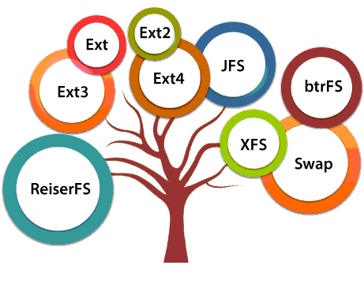
1. Ext, Ext2, Ext3 and Ext4 file system:-
The file system Ext stands for Extended File System. It was primarily developed for MINIX OS. The Ext file system is an older version, and is no longer used due to some limitations.
Ext2 is the first Linux file system that allows managing two terabytes of data. Ext3 is developed through Ext2; it is an upgraded version of Ext2 and contains backward compatibility. The major drawback of Ext3 is that it does not support servers because this file system does not support file recovery and disk snapshot.
Ext4 file system is the faster file system among all the Ext file systems. It is a very compatible option for the SSD (solid-state drive) disks, and it is the default file system in Linux distribution
2. JFS File System:-
JFS stands for Journaled File System, and it is developed by IBM for AIX Unix. It is an alternative to the Ext file system. It can also be used in place of Ext4, where stability is needed with few resources. It is a handy file system when CPU power is limited.
3. ReiserFS File System:-
ReiserFS is an alternative to the Ext3 file system. It has improved performance and advanced features. In the earlier time, the ReiserFS was used as the default file system in SUSE Linux, but later it has changed some policies, so SUSE returned to Ext3. This file system dynamically supports the file extension, but it has some drawbacks in performance.
4. XFS File System:-
XFS file system was considered as high-speed JFS, which is developed for parallel I/O processing. NASA still using this file system with its high storage server (300+ Terabyte server)
5. Btrfs File System:-
Btrfs stands for the B tree file system. It is used for fault tolerance, repair system, fun administration, extensive storage configuration, and more. It is not a good suit for the production system.
6. Swap File System:-
The swap file system is used for memory paging in Linux operating system during the system hibernation. A system that never goes in hibernate state is required to have swap space equal to its RAM size.

